WebsitePanel Installation Guide

Author: Feodor Fitsner  
Last updated:   
Version: 1.0

Table of Contents

Introduction 2

Hardware Requirements 2

Dedicated Server 2

Dedicated IP Addresses 2

Internet Access 2

Software Requirements 3

How Does WebsitePanel Work 3

WSP Portal 4

WSP Enterprise Server 4

WSP Server 5

Common Deployment Scenarios 5

Preparing Server for the Installation 5

Web Platform Installer 6

Windows Server 2003 7

Windows Server 2008 14

Configuring SQL Server 25

Installing DNS Service 28

Installing MySQL Server 35

Installing WebsitePanel 39

Installing WebsitePanel “Standalone” Package 39

Installing WebsitePanel Components One-by-One 44

WebsitePanel Enterprise Server 44

WebsitePanel Portal 45

WebsitePanel Server 47

Troubleshooting Installation Issues 48

Configuring WebsitePanel Components 50

Changing WebsitePanel Web Site Settings 50

Changing Enterprise Server URL in Portal Settings 51

Changing Enterprise Server “serveradmin” Password 51

Changing Server Access Password 51

Upgrading WebsitePanel Components 52

Troubleshooting Upgrade Issues 52

Document History 52

# Introduction

This guide includes steps required to prepare hosting environment for WebsitePanel installation, the process of installing and upgrading WebsitePanel components as well as possible post-installation troubleshooting options.

The target audience for this guide is system administrators performing WebsitePanel installation and maintenance tasks.

# Hardware Requirements

## Dedicated Server

In order to install WebsitePanel and make your hosting business you need a dedicated internet server. We don't dictate any specific requirements for your hardware; typical server with 1GB RAM and 40GB HDD configuration is quite enough for WebsitePanel to operate. The rule is simple - more powerful server you have the more user accounts, web sites, databases, etc. you can create on it.  
You should have an administrative access either local or via Remote Desktop to manage your server, i.e. install and configure server software, check system logs, etc.

## Dedicated IP Addresses

If you are planning to host and manage DNS and mail software on your server, it is recommended you have at least 2 (two) dedicated IP addresses pointing to your server. Of course, you may install and configure everything using only one IP address, but generally it's not a good practice, because at the end you'll get incorrect DNS zones and mail exchangers. So, purchase at least 2 IP addresses from your dedicated server hosting provider.

## Internet Access

Your dedicated server must be connected to the Internet in order to install and configure WebsitePanel components.

# Software Requirements

### Operating System

The following operating systems are supported:

* Windows Server 2003
* Windows Server 2003 R2
* Windows Server 2008
* Windows Server 2008 R2

Any edition of operating systems above is supported.

Both 32-bit and 64-bit editions are supported.

### Web Server

* Internet Information Services (IIS) must be installed to host WebsitePanel components.

### Database Server

SQL Server is required to host internal WebsitePanel database. WebsitePanel database could be installed on the following SQL Server versions:

* SQL Server 2005 Express edition or above
* or SQL Server 2008 Express edition or above

SQL Server Express edition could be used to host WebsitePanel database which is free and could be downloaded from this location:  
<http://www.microsoft.com/express/sql/download/>

### Virtualized Environments

WebsitePanel could be installed on a physical dedicated server or virtual machine hosted in one of the following virtualization environments:

* Microsoft Hyper-V
* Microsoft Virtual PC
* Virtuozzo
* VmWare
* XenServer

# How Does WebsitePanel Work

WebsitePanel is a distributed web-based application and it consists of three components working together:

* WSP Portal
* WSP Enterprise Server
* WSP Server



All three components are web applications that must be hosted in either IIS 6 or IIS 7.

## WSP Portal

WSP Portal is a “user interface” (or presentation layer) part of WebsitePanel. It is ASP.NET application that does not contain any business logic at all, but it talks to WSP Enterprise Server via SOAP to perform various operations. Every visual form, any button click invokes appropriate web service at Enterprise Server side.

WSP Portal web application is accessible to external consumers and works in IIS application pool with “weak” identity.

## WSP Enterprise Server

WSP Enterprise Server is the most important WSP component that comprises all the business logic of the application. Enterprise Server uses SQL Server database to store its internal data like user accounts, hosting plans, info about hosted resources, service settings, etc.

Absolutely every operation in WebsitePanel is available as an XML web service, so those web services could be used for integration with 3rd-party applications. It’s possible to access WSP Enterprise Server practically from any programming environment like .NET, PHP, Java or Perl.

To manage hosting environment (create web sites, FTP and mail accounts, databases, etc.) Enterprise Server communicates to WSP Server using XML web services.

Enterprise Server is a non-visual web application (no web forms exposed, only web services) and usually it’s available only to computers in your hosting environment (web site listens internal IP addresses only or “loop-back” 127.0.0.1). Enterprise Server application pool works under “weak” identity.

## WSP Server

WSP Server is non-visual web application performing low-level management operations (working with files/folders and their permissions, working with mail and databases, working with IIS, etc.) on the target server(s).

WSP Server could be considered as remote “Server Agent” and it must be installed on every server in the hosting environment that needed to be managed in control panel. WSP Server runs in the application pool with administrative privileges, i.e. its application pool’s identity must be a member of local “Administrators” group or “Domain Admins” group if AD must be managed as well.

## Common Deployment Scenarios

### “Standalone” Setup



### “Multi-Server” Setup



# Preparing Server for the Installation

Before installing WebsitePanel your server must be configured and certain prerequisite software must be installed. Configuration process is different for both Windows Server 2003 and 2008.

## Web Platform Installer

The easiest way to prepare Windows Server 2003 or 2008 for installing WebsitePanel is to use Microsoft Web Platform Installer.

Microsoft Web Platform Installer (Web PI) enables you to easily install and configure the following products:

* Internet Information Services
* .NET Framework 2.0
* .NET Framework 3.5 SP1
* SQL Server 2008 with Management Studio Express
* PHP 5.x
* other libraries and programs

You could download Web PI from the following location:  
<http://www.microsoft.com/web/downloads/platform.aspx>

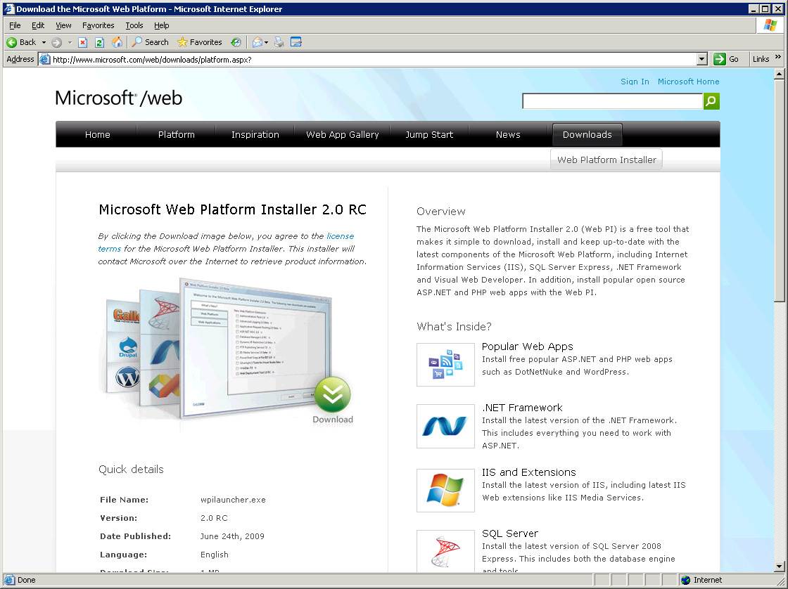

On clean Windows Server 2003 installation during the first run Web IP will ask about .NET 2.0. Click “OK” to allow installation of .NET 2.0:

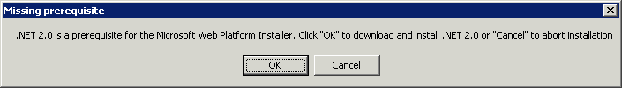

## Windows Server 2003

Run “Web Platform Installer”.

On the main screen of Web PI you could see the list of latest products and libraries available for the current platform (Windows Server 2003). Tick “Web Deployment Tool 1.0 RC” item to install MS Deploy library. This library is required for WebsitePanel to integrate with Microsoft Web App Gallery module:

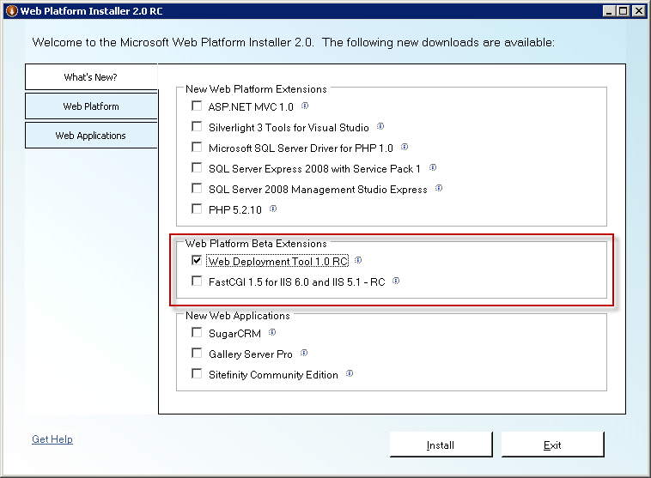

Click “Web Platform” tab and then click “Customize” link in “Web Server”. Tick web server components as shown on the figure below:

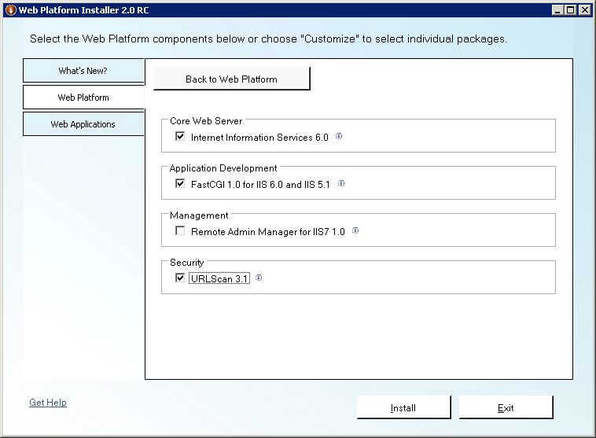

Click “Back to Web Platform” button to return on previous screen.

Click “Customize” link in “Frameworks and Runtimes” section. Tick framework components as shown on the figure below:

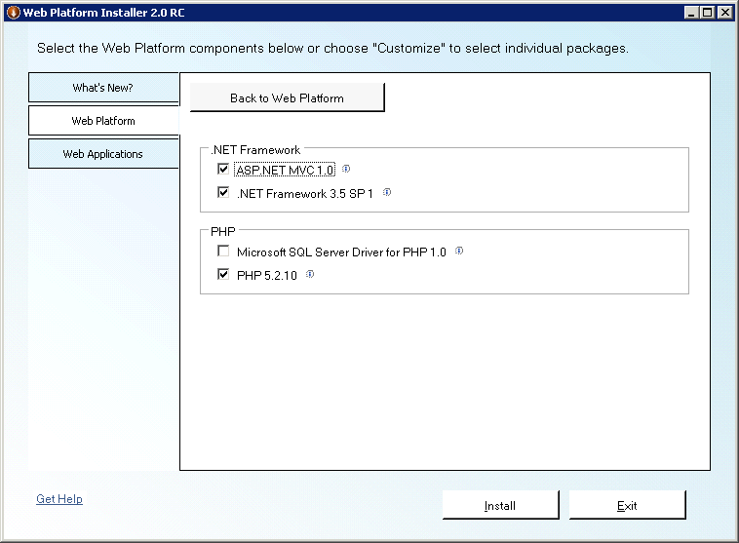

Note that ASP.NET MVC is not necessary for WebsitePanel, but would be beneficial for your customers.

Click “Back to Web Platform” button to return on previous screen.

Click “Customize” button in “Database” section. Tick database components as shown on the figure below:

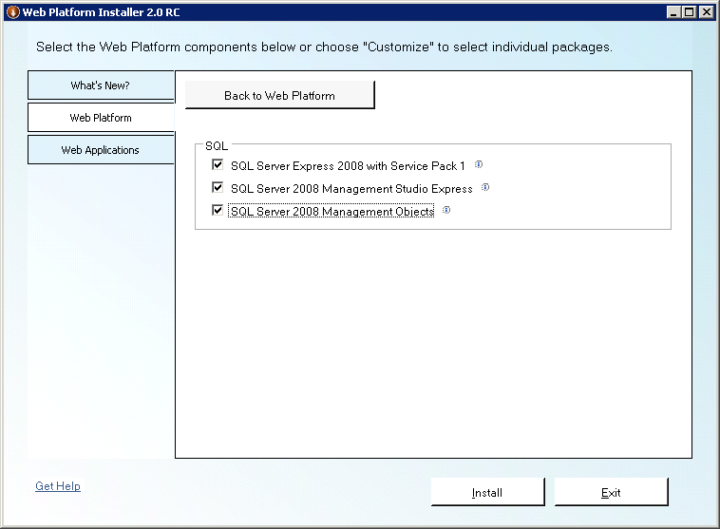

Click “Back to Web Platform” button to return on previous screen.

Optionally, you could go to “Tools” section and install Visual Web Developer with Silverlight, but those components are not required for WebsitePanel installation.

Click “Install” button to start the installation of selected components. Click “I Accept” button to agree to licensing terms for selected components. Before installing SQL Server 2008 you will be asked about its security mode. You have to select “Mixed Mode Authentication” and then specify password for “sa” account:

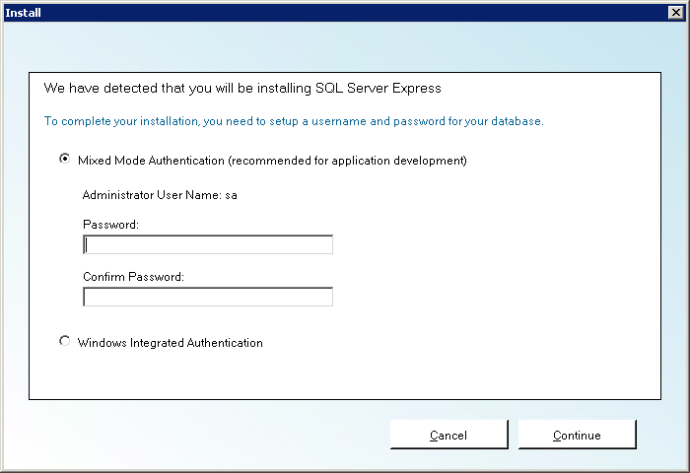

During the installation all selected products will be downloaded from their respective locations and then installed:

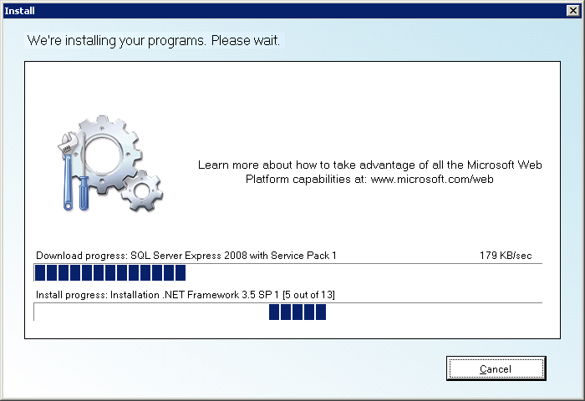

During the installation of Windows components you may be asked to provide a path to Windows Server 2003 distributive.

After the installation process is finished you get complete environment for hosting web applications with IIS 6, all .NET Frameworks and their latest service packs and SQL Server 2008 installed:

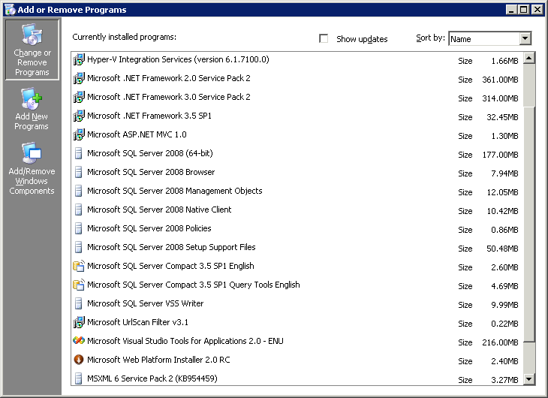

### Enabling PHP Extension

After installing PHP with Web PI you have to enable PHP extension in IIS.

Open IIS manager, right-click "Web Service Extensions" in the left navigation tree and select "Add new Web service extension..." from expanded menu:

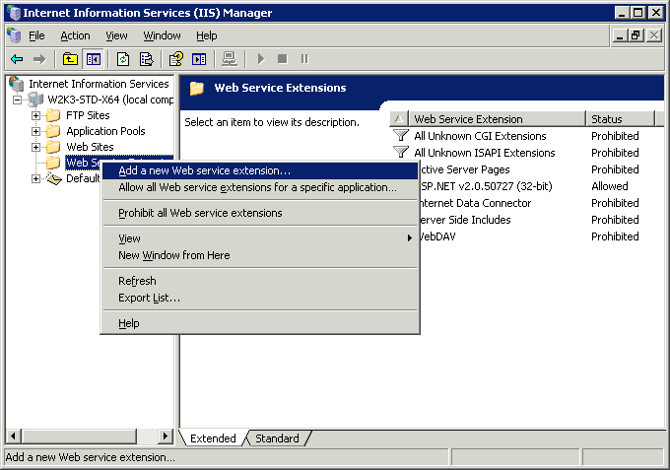

Specify "PHP 5" as extension name, select path to php-cgi.exe file and tick "Set extension status to Allowed" checkbox:

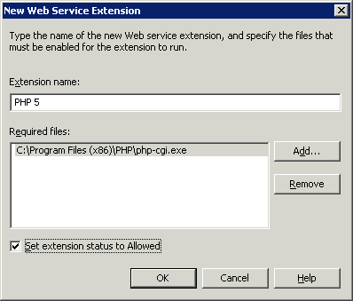

Click "OK" button to add extension.

### Installing FTP and SMTP Services

In order to use FTP client to work with files and folders on the server you have to install Microsoft FTP Service that is part of IIS 6 platform. To send notifications from WebsitePanel you have to install SMTP service which is also a part of IIS 6.

To install FTP and SMTP services go to “Control Panel -> Add/Remove Programs -> Add/Remove Windows Components”. Click “Details...” button on “Application Server” item then “Details...” button again on “Internet Information Services (IIS)” item. Tick both “File Transfer Protocol (FTP) Service” and “SMTP Service” items and click “OK” on all opened dialogs to start the installation:

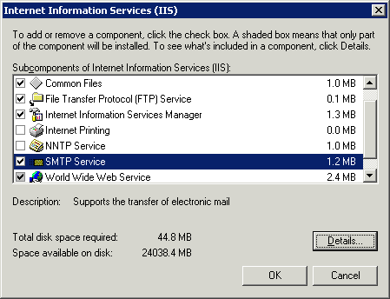

### Configuring IIS Logging

In order to collect and analyze consumed web sites traffic in WebsitePanel you have to enable logging in IIS. By default logging in the correct format is already on, but some important options are not enabled.

Open IIS Manager snap-in, right-click on “Web Sites” node and then select “Properties”. In the opened dialog click “Properties...” button in “Enable logging” section and then switch to “Advanced” tab. Tick “Bytes sent” and “Bytes received” columns:

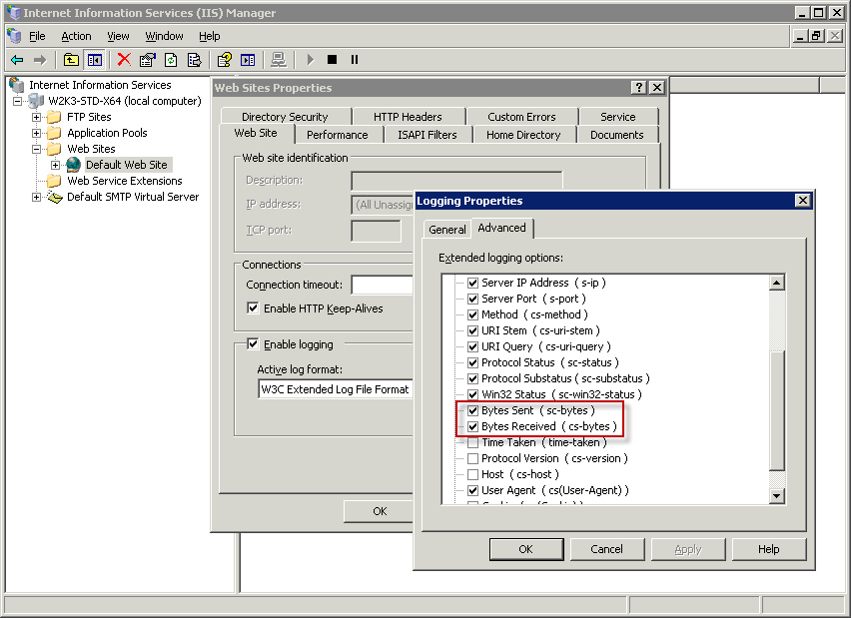

Click “OK” button on all dialogs to save settings.

### Disabling Password Complexity Policy

To disable password complexity policy open “Local Security Settings” snap-in (Start -> Administrative Tools) and then expand “Account Policies -> Password Policy” node. Set “Password must meet complexity requirements” to disabled.

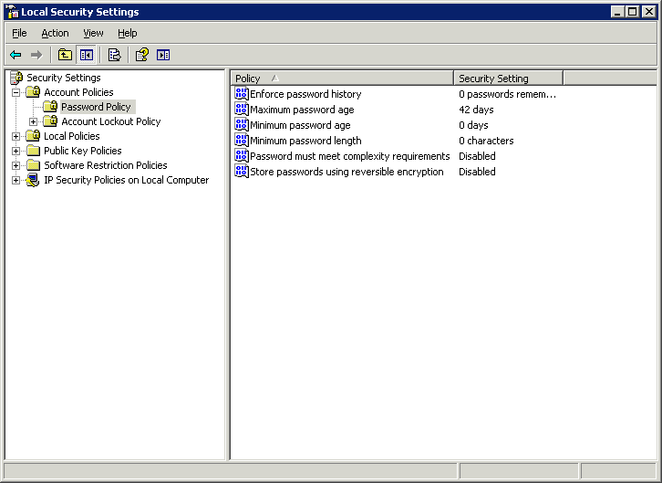

## Windows Server 2008

Run “Web Platform Installer”.

On the main screen of Web PI you could see the list of latest products and libraries available for the current platform (Windows Server 2008). Tick “Web Deployment Tool 1.0 RC” item to install MS Deploy library. This library is required for WebsitePanel to integrate with Microsoft Web App Gallery module:

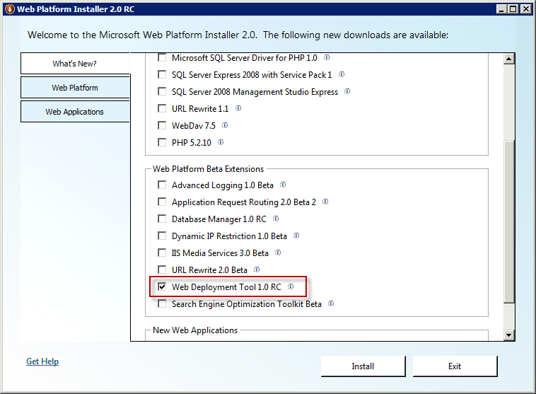

Click “Web Platform” tab and then click “Customize” link in “Web Server”. Tick the following web server components:

* Common HTTP Features
  + Static Content
  + Default Document
  + HTTP Errors
  + HTTP Redirection
  + URL Rewrite 1.1
* Application Development
  + ASP.NET
  + CGI
* Deployment and Publishing
  + FTP Publishing Service 7.5
* Management
  + IIS Management Console
* Security
  + Basic Authentication
  + Windows Authentication

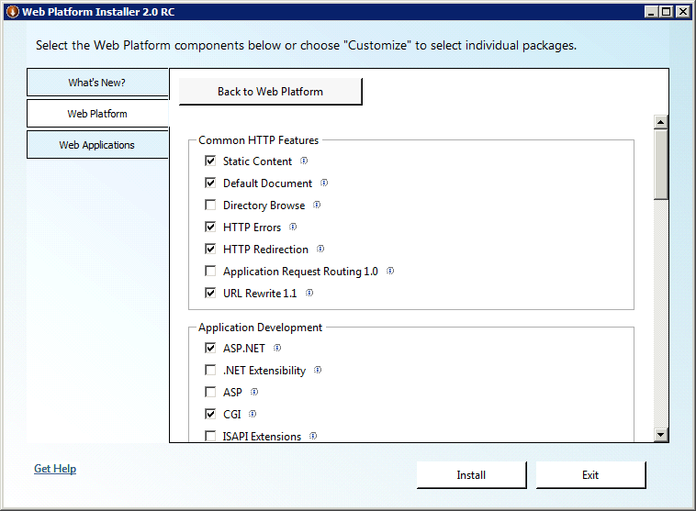

Click “Back to Web Platform” button to return on previous screen.

Click “Customize” link in “Frameworks and Runtimes” section. Tick framework components as shown on the figure below:

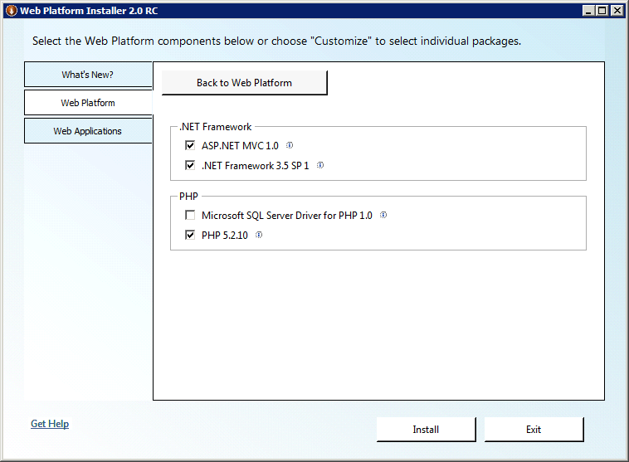

Click “Back to Web Platform” button to return on previous screen.

Click “Customize” button in “Database” section. Tick database components as shown on the figure below:

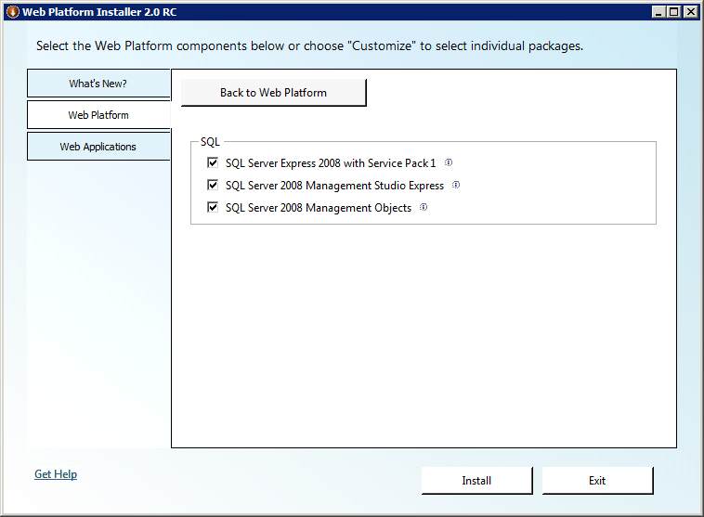

Click “Back to Web Platform” button to return on previous screen.

Optionally, you could go to “Tools” section and install Visual Web Developer with Silverlight, but those components are not required for WebsitePanel installation.

Click “Install” button to start the installation of selected components. Click “I Accept” button to agree to licensing terms for selected components:

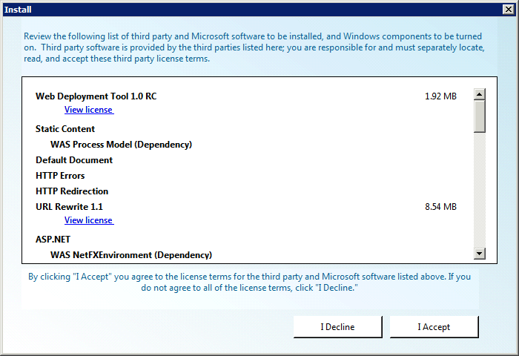

Before installing SQL Server 2008 you will be asked about its security mode. You have to select “Mixed Mode Authentication” and then specify password for “sa” account:

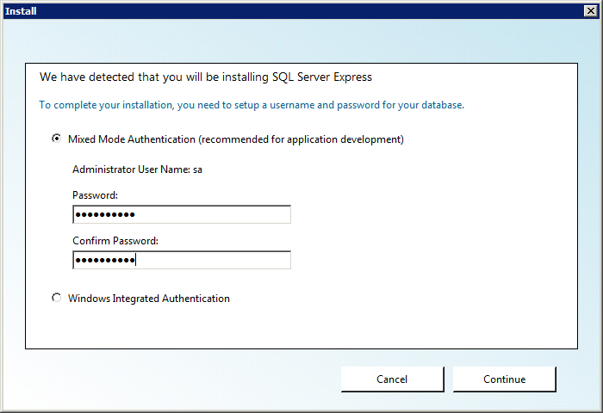

During the installation all selected products will be downloaded from their respective locations and then installed:

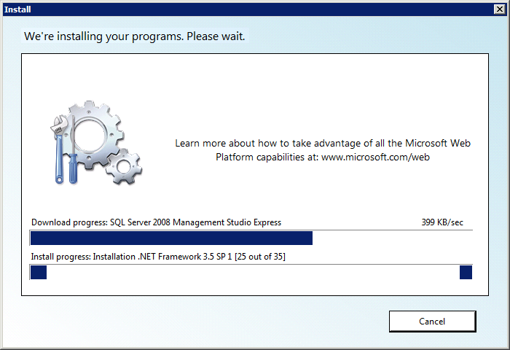

### Configuring IIS 7 Logging

In order to collect and analyze consumed web sites traffic in WebsitePanel you have to enable logging in IIS. By default logging in the correct format is already on, but some important options are not enabled.

Open IIS Manager snap-in and click server name node:

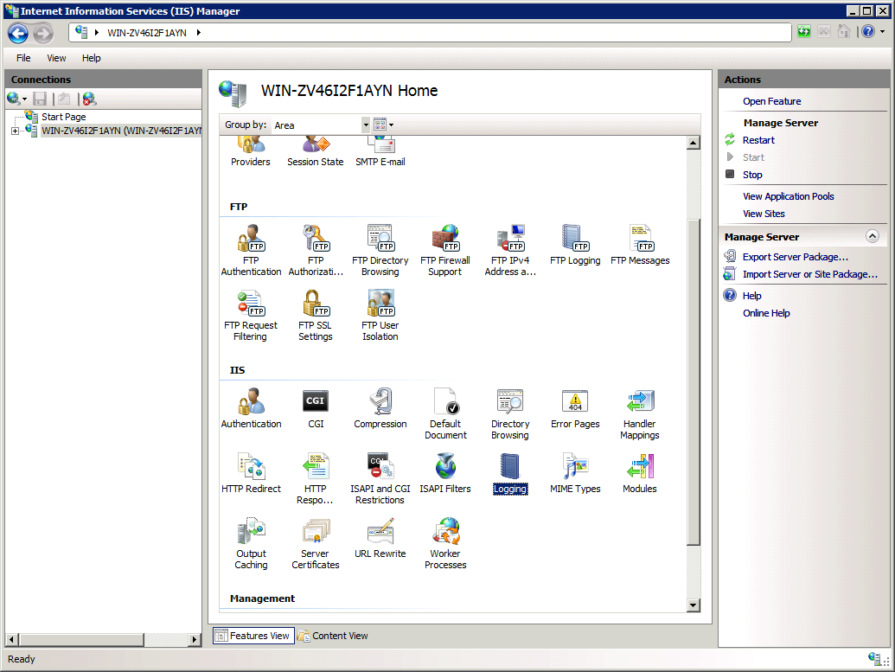

Click “Logging” under “IIS” section:

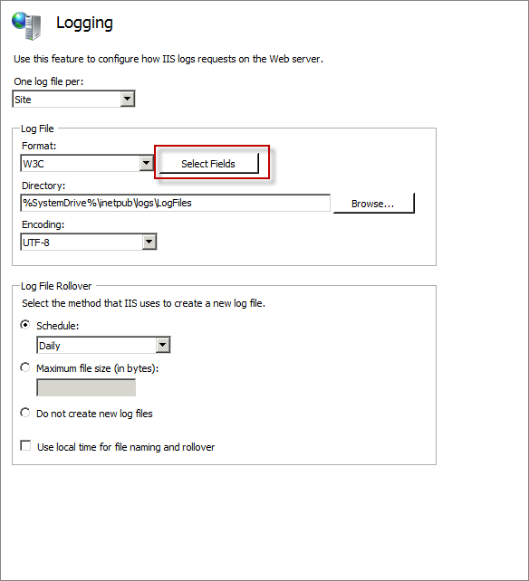

And then click “Select Fields” button:

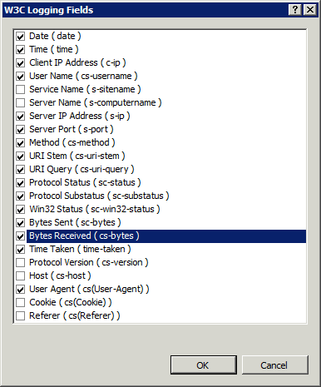

Tick “Bytes sent” and “Bytes received” columns and click “OK” to save changes.

### Creating Default FTP Site

In order to manage files and folders on your server from FTP client you have to configure default FTP site. All FTP accounts then will be created under this FTP site. It is supposed “FTP Services 7.5” were installed on the previous step using Web Platform Installer.

Open “Administrative Tools -> Computer Management” and click “Local Users and Groups -> Groups” node:

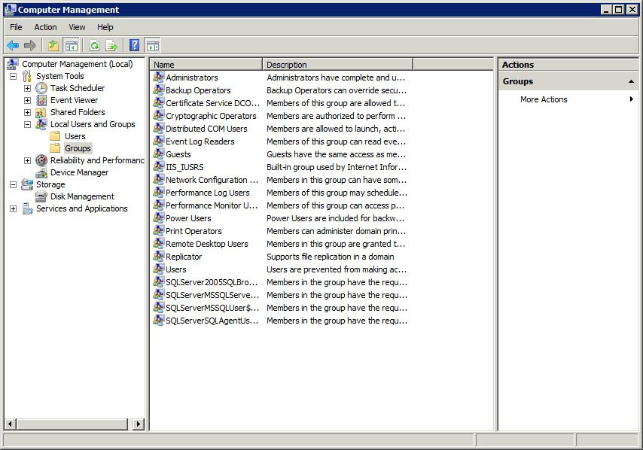

Add a new group called “WSPFtpUsers”.

Open Windows Explorer and navigate to c:\inetpub folder. Create a new folder called “ftproot” and for this folder give “Read” NTFS permissions to “WSPFtpUsers” group:

[SCREENSHOT]

Open IIS Manager and expand “Sites” node:

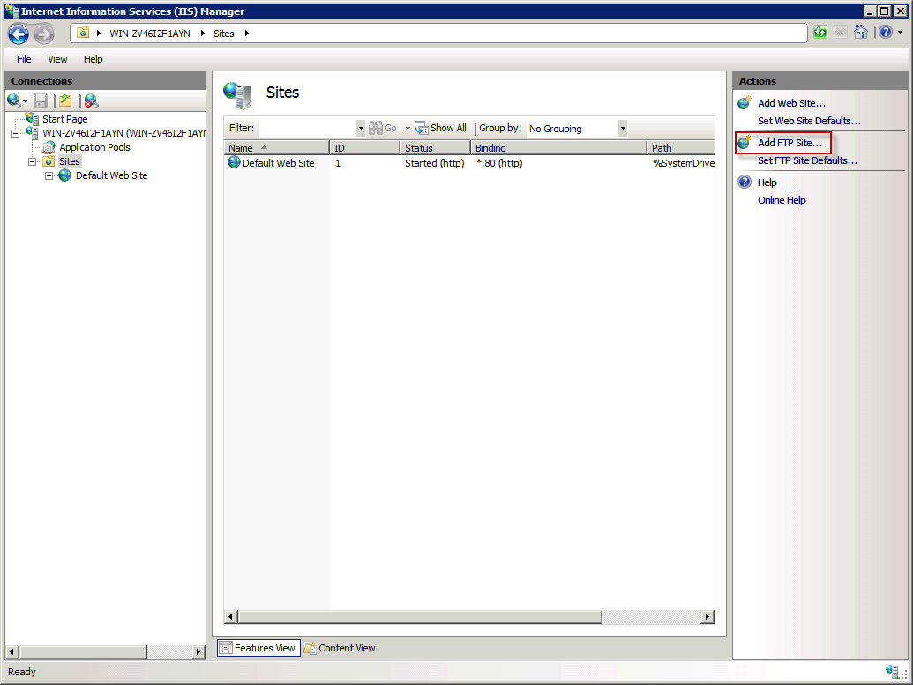

Click “Add FTP Site” link on “Actions” pane:

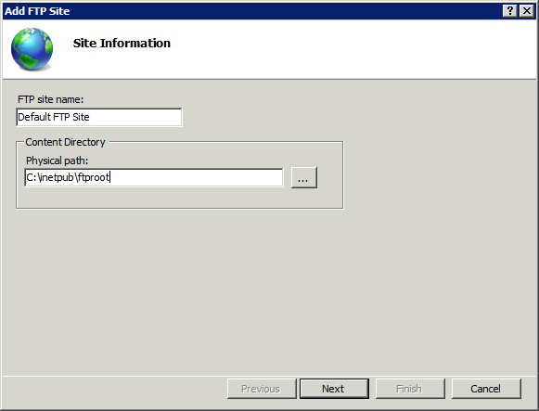

Specify FTP site name and root folder path. Click “Next”:

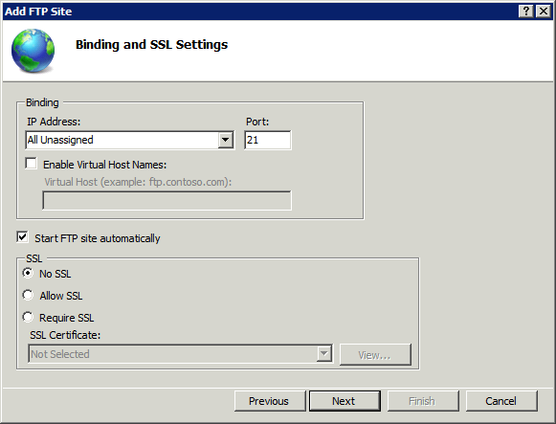

On this step specify FTP site bindings and select “No SSL” required to use FTP protocol rather than FTPS. If you decide to setup SSL certificate and utilize FTPS protocol this settings could be changed later.

Click “Next” to go to the next screen:

[SCREENSHOT]

Tick “Basic” for authentication and allow “Read” access to “WSPFtpUsers” group. Click “Finish” to creae FTP site. Click “Finish” to create FTP site.

Click “Default FTP Site” node and then click “FTP User Isolation” icon:

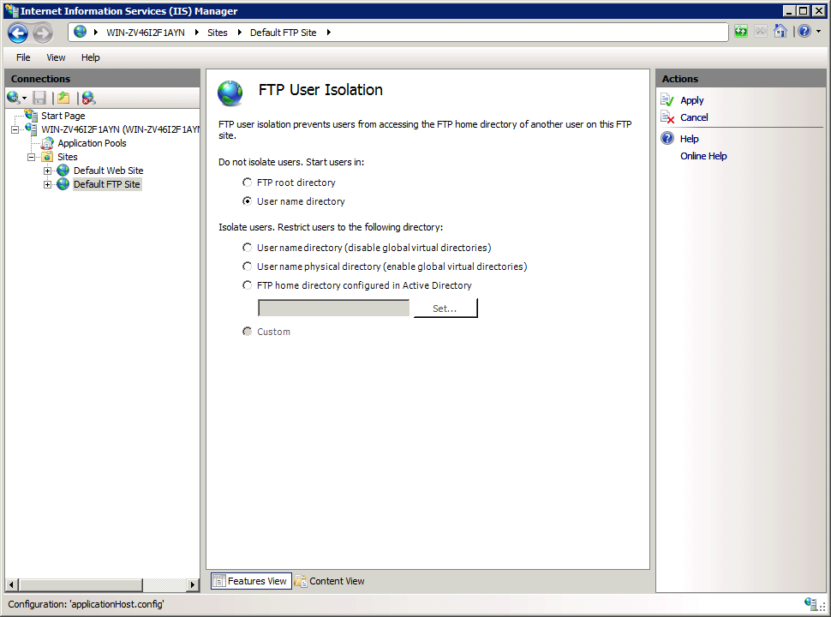

Switch isolation mode to “User name directory” and click “Apply” to save changes.

### Disabling Password Complexity Policy

To disable password complexity policy open “Local Security Policy” snap-in (Start -> Administrative Tools) and then expand “Account Policies -> Password Policy” node. Set “Password must meet complexity requirements” to disabled.

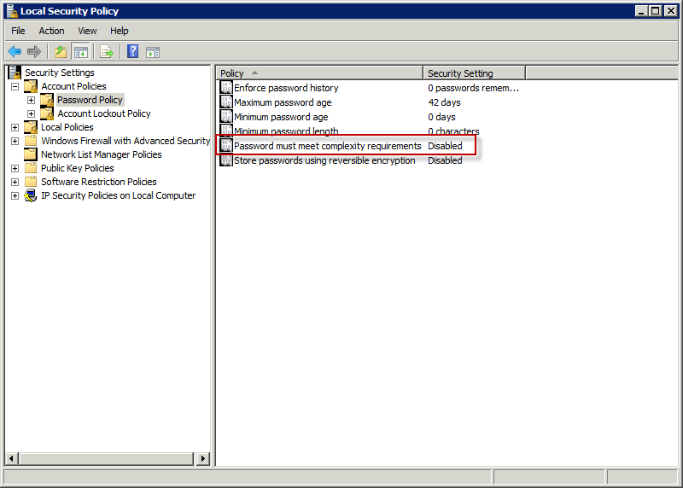

## Configuring SQL Server

### Adding "Administrators" group to server administrators

You could skip this step if you are installing "WebsitePanel Standalone Setup" package as WSPServer account will be added into "sysadmin" group automatically by WSP Installer.

In order to manage SQL Server from WebsitePanel using Windows Authentication (where account credentials to access SQL Server instance are not stored in WebsitePanel database) you have to add Windows "Administrators" group to "sysadmin" role of SQL Server.

To do that open SQL Server Management Studio, right-click on "Security -> Logins" node and select "New Login...":

[SCREENSHOT]

"New Login" dialog will be opened:

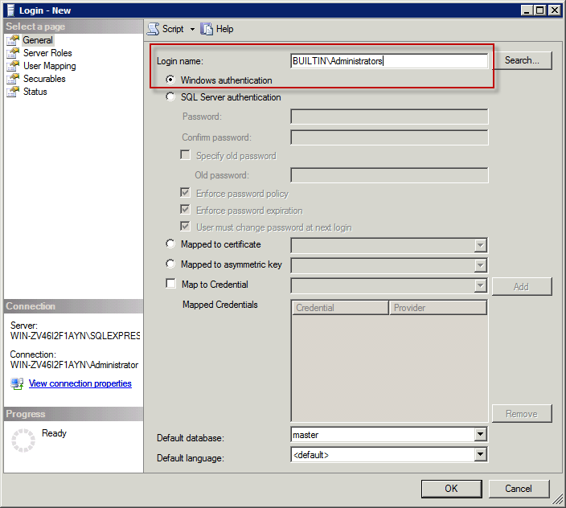

Specify "BUILTIN\Administrators" as "Login name" and then switch to "Server Roles" tab:

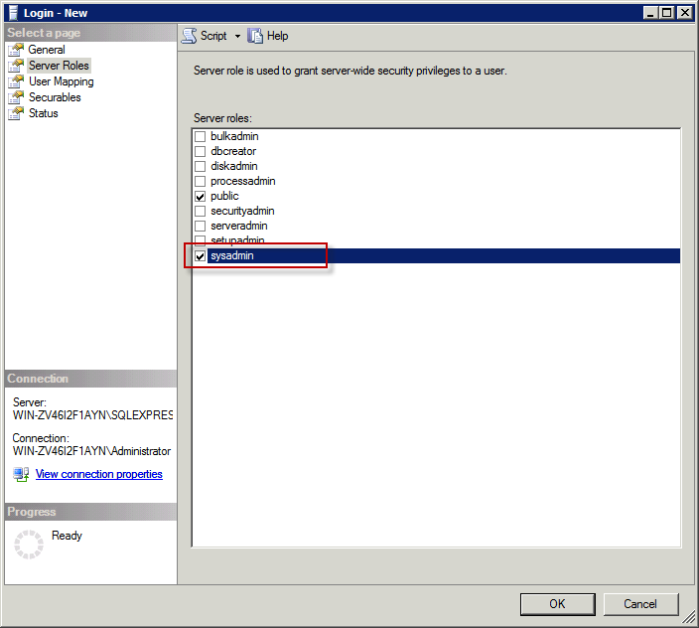

Tick "sysadmin" role and click "OK" button to add a new group:

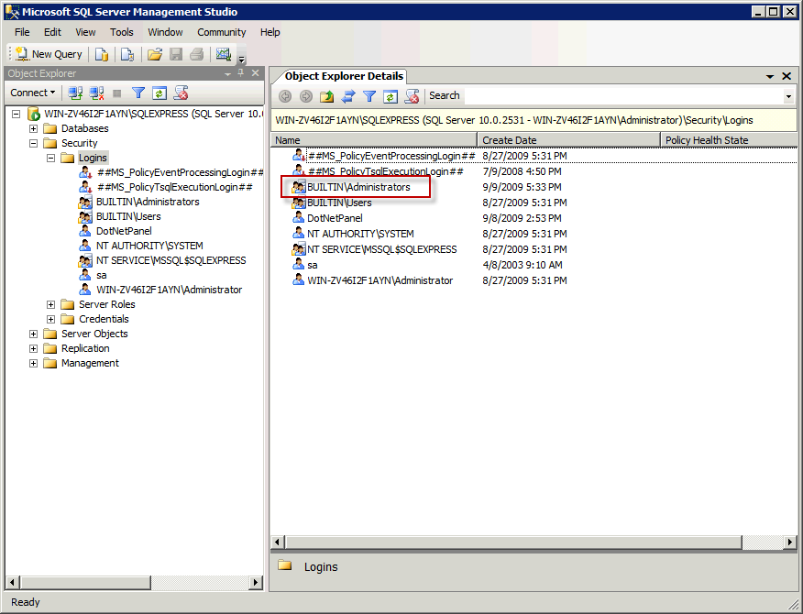

### Configuring SQL Server to accept external connections

To enable SQL Server Express installed on the server accept external connections via TCP/IP you could use the following Microsoft KB:  
<http://support.microsoft.com/kb/914277>

This article works well for both SQL Server 2005 and 2008.

## Installing DNS Service

### Installing DNS Service on Windows Server 2003

Open "Control Panel" and then On "Add/Remove Windows Components":

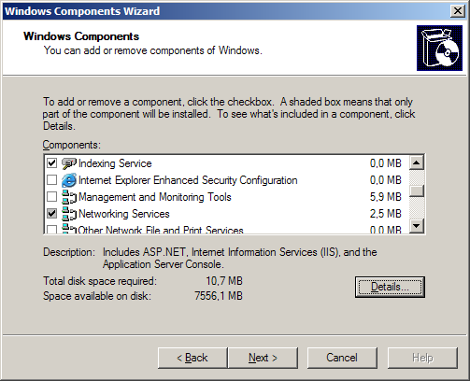

Click "Details..." button on "Networking Services":

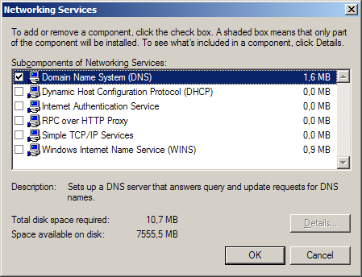

Tick "Domain Name System (DNS)" and then click "OK" button. Click "Next" button to finish DNS service installation.

### Installing DNS Service on Windows Server 2008

Open "Server Manager":

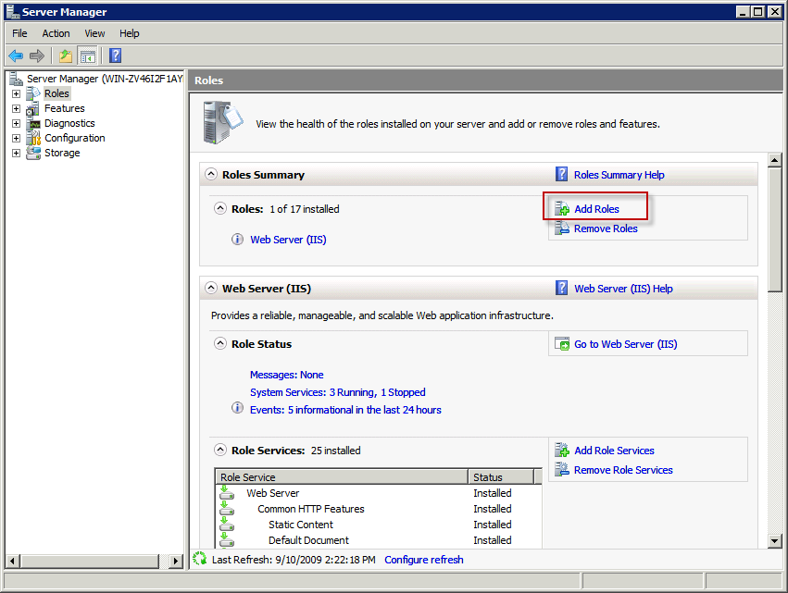

Highlight "Roles" node in the left navigation tree and then click "Add Roles" link:

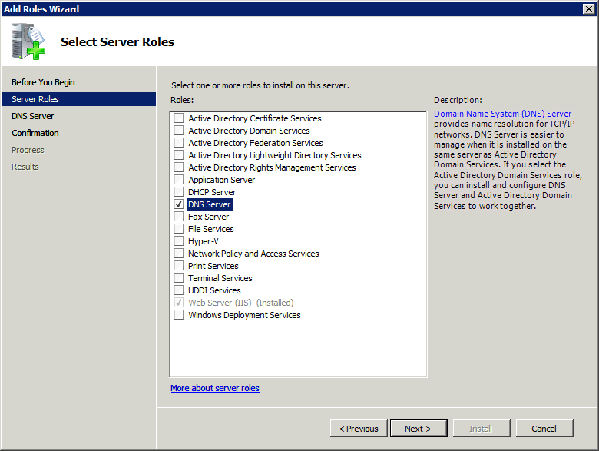

Tick "DNS Server" role and click "Next" button to continue. Follow the wizard and finally click "Install" to perform the installation of selected roles:

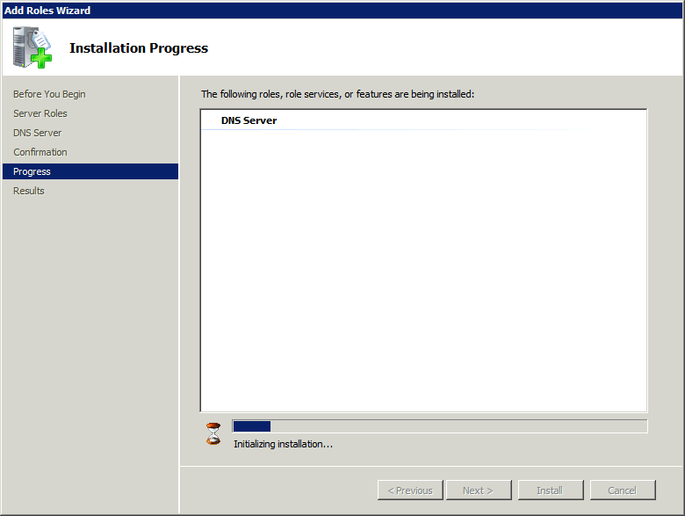

### Configuring DNS Service

Before starting configuring DNS Server you should have the domain name registered with some registrar, e.g. GoDaddy. We will be using sample "abc.com" domain name in all examples below.

When configuring your DNS Server, please replace "abc.com" with your registered domain name.

Open "DNS" snap-in (click "Start -> Administrative Tools -> DNS"):

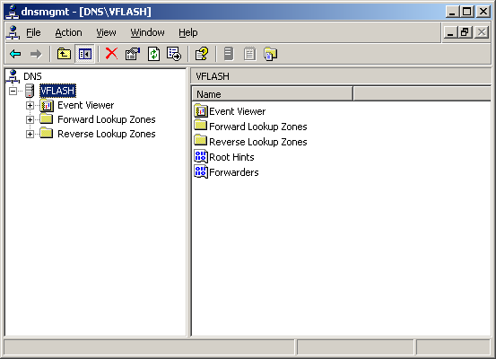

Right-click on the node with the name equal to your computer name and select "Properties". On "Interfaces" tab select "Only the following IP addresses" option and specify at least two IP addresses from your server's IP addresses pool:

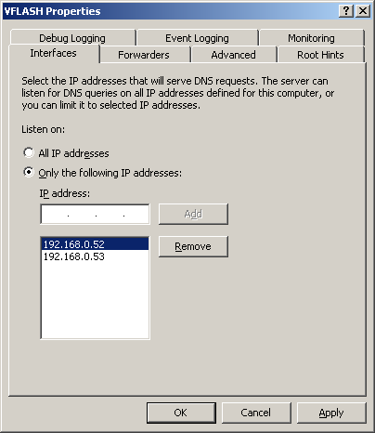

Click on the "Advanced" tab and tick the checkboxes as on the picture below:

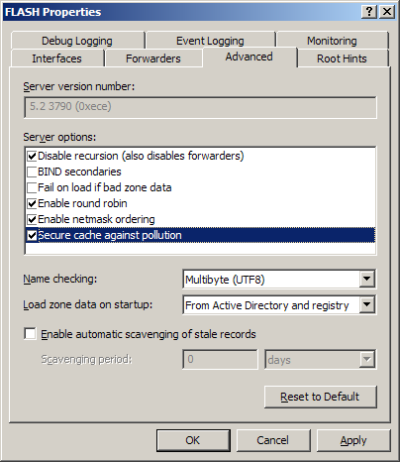

Click "OK" button to update DNS service settings.

### Configuring Custom Name Servers

In order to get your personal Name Server records you should create at least one DNS primary zone.

In "DNS" snap-in right-click "Forward Lookup Zones" node and select "New Zone...". With the help of wizard create a new primary zone "abc.com":

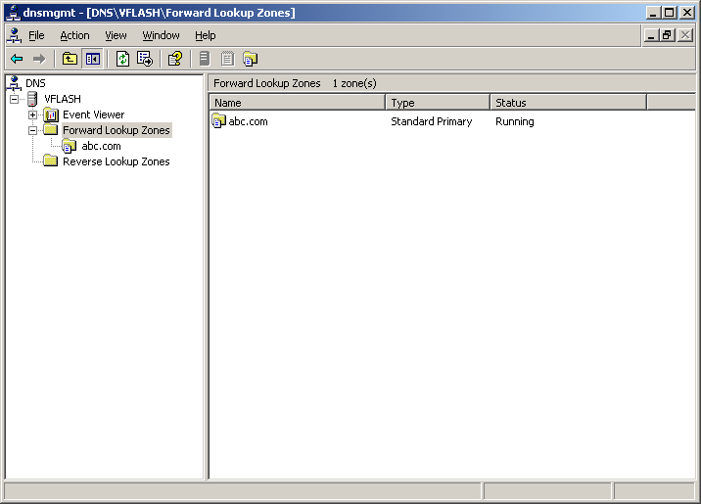

Create two "NS1" and "NS2" "A" records pointing to two different IP addresses.

Right click "abc.com" node and select "Properties". Click "Name Servers" tab and add references to the created name servers "ns1.abc.com" and "ns2.abc.com".

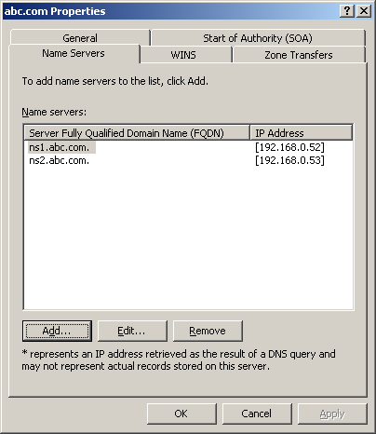

Switch to "Start of Authority (SOA)" tab and change SOA record settings:

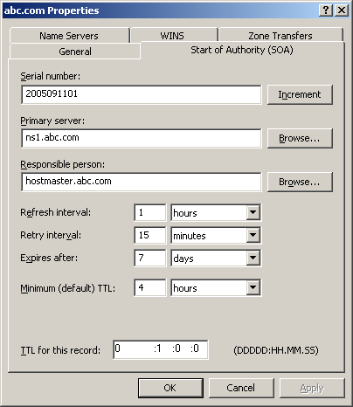

Serial number should be in the format of "YYYYMMDDNN" where YYYY - current year, MM - current month, DD - current day and NN - this number should start with 01 each new day and be incremented by 1 each time you change DNS zone.

Primary server is the name of the "NS1" Name Server created on the previous step.

Specify responsible person value which is an e-mail of the person that can be contacted in case of any questions regarding current DNS zone.

Change time settings as shown on the picture above.

Click "OK" to save your changes and close the dialog.

Add other zone records:

* Four "A" records "*", "ftp", "mail", "www" with the corresponding IP addresses
* One MX record pointing to "mail.abc.com." with 10 priority
* One TXT record with "v=spf1 a mx -all" which is so-called "SPF" record.

The complete zone should look like on the picture below:

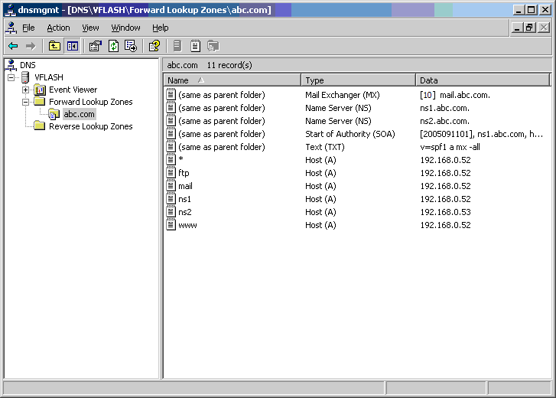

## Installing MySQL Server

Many applications written in PHP require MySQL database server. You could download free “MySQL Community Server” from the following location:  
<http://dev.mysql.com/downloads/mysql/5.1.html>

Select your platform (Windows and then 32- or 64-bit edition) and then download “Windows Essentials” package (usually it’s a smallest one under selected platform).

Run the installation wizard and select “Typical” on “Setup Type” step:

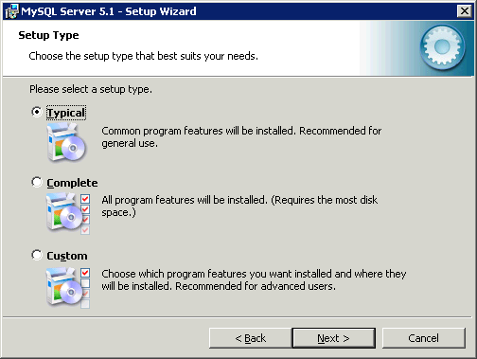

After the installation is completed proceed to MySQL service configuration:

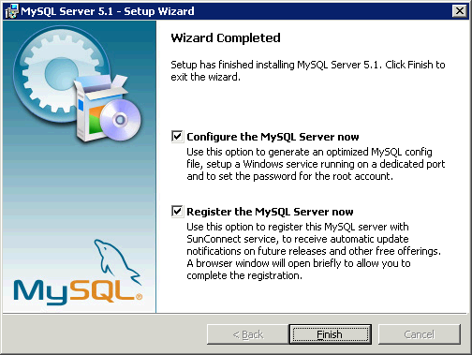

Select “Standard Configuration” and click “Next” button:

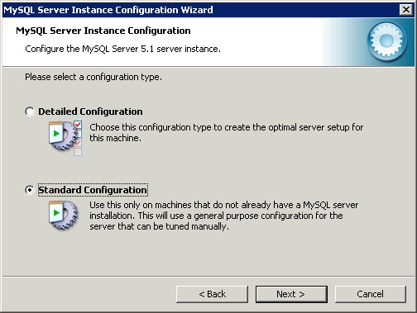

Specify settings for MySQL Windows service:

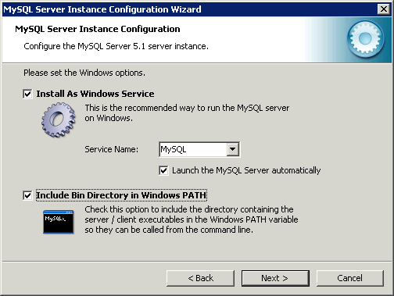

And then specify a password for “root” account:

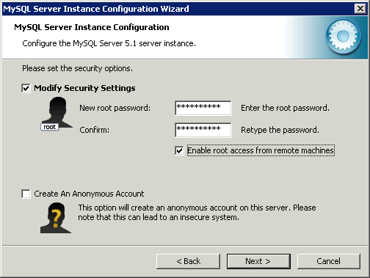

Click "Enable root access from remote machines". In some cases this could simplify configuring MySQL for your applications.

At the next step click "Execute" button. All configuration steps must be successfully completed:

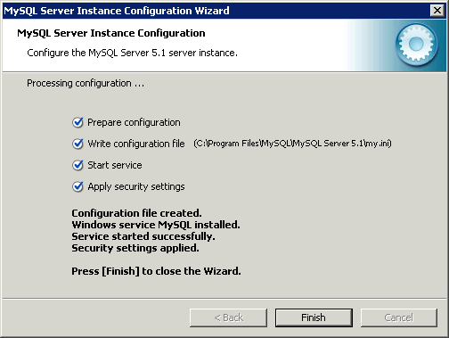

To test MySQL service you could open command line interface, switch to MySQL installation folder and perform some commands (e.g. display the list of available databases) against MySQL engine as shown on the figure below:

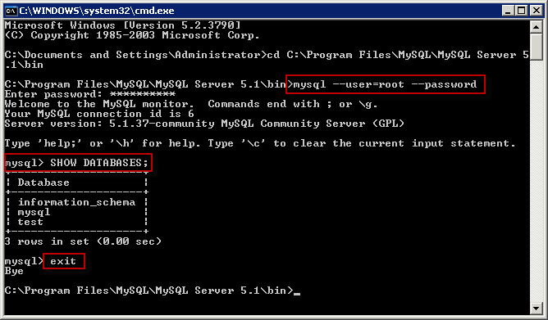

# Installing WebsitePanel

WebsitePanel Installer (WSPI) is a program for installing and upgrading WebsitePanel components. WSPI has a small size and it does not contain WebsitePanel components installation files, but those files will be downloaded during WebsitePanel installation or upgrade.

In order to install WebsitePanel you have to install WSPI on the server. Go to [www.WebsitePanel.net](http://www.WebsitePanel.net), then click on Downloads link on the right navigation pane:

[SCREENSHOT]

Download and install WebsitePanel Installer:

[SCREENSHOT]

After WSPI installation is completed click “WebsitePanel Installer” shortcut on server desktop to run WSPI, then click ‘View Available Components’:

[SCREENSHOT]

# Installing WebsitePanel “Standalone” Package

"Standalone Server Setup" package installs WSP Portal, WSP Enterprise Server and WSP Server components on the server and then automatically configure WebsitePanel installation by registering services, creating hosting plan, user account and hosting space.

"Standalone" installation package is very handful for those customers who would like to use WebsitePanel to manage their dedicated server or VPS.

In order to install "Standalone" package open WSP Installer (WSPI), highlight "Components" node and click "View Available Components" button. Click "Install" link on "Standalone Server Setup" line. Please note that this component will be visible if there are no WSP components installed on the server:

[SCREENSHOT]

Please be patient as it could take some time to download installation files from WebsitePanel web server.

After installation files are downloaded welcome step of installation wizard will appear:

[SCREENSHOT]

Click "Next" to continue and then accept WebsitePanel license to proceed with the installation.

WSPI will perform a check for system requirements:

[SCREENSHOT]

On "Web Settings" step you could specify WebsitePanel web site bindings. The URL shown on this page will be used to access your control panel. If you have a free IP address assigned to the server then we recommend to dedicate it for control panel and specify "80" for the port; otherwise in the case selected IP is shared by several web sites we recommend you to leave default IP address and 9001 port.

Make sure the custom port selected for this web site (9001 in our case) is allowed on server Firewall.

[SCREENSHOT]

Click "Next" button to switch to the next step:

[SCREENSHOT]

Specify password for "serveradmin" account. "Serveradmin" account is a root account in WebsitePanel with administrative privileges. Also, this password will be set for "admin" account. "Admin" account belongs to "users" role and you use this account to manage your server resources.

Click "Next" button to install WebsitePanel components:

[SCREENSHOT]

Three WSP components (Portal, Enterprise Server and Server) will be installed and configured.

After successful installation you will be presented with the following screen:

[SCREENSHOT]

You could check setup log to see if there any issues and click "Log on to WebsitePanel" link open WebsitePanel sign in screen.

To sign in to control panel use "admin" account with the password specified during the installation.

Click "Finish" button to finish installation wizard:

[SCREENSHOT]

Under "Components" node you will see all three WSP components installed.

### Allowing WebsitePanel Portal on Windows Firewall

By default WSP Portal component (User Interface part of WebsitePanel) is installed on 9001 TCP port. To access WebsitePanel from the Internet make sure 9001 port is open on a firewall.

Go to "Control Panel" and open "Windows Firewall" snap-in:

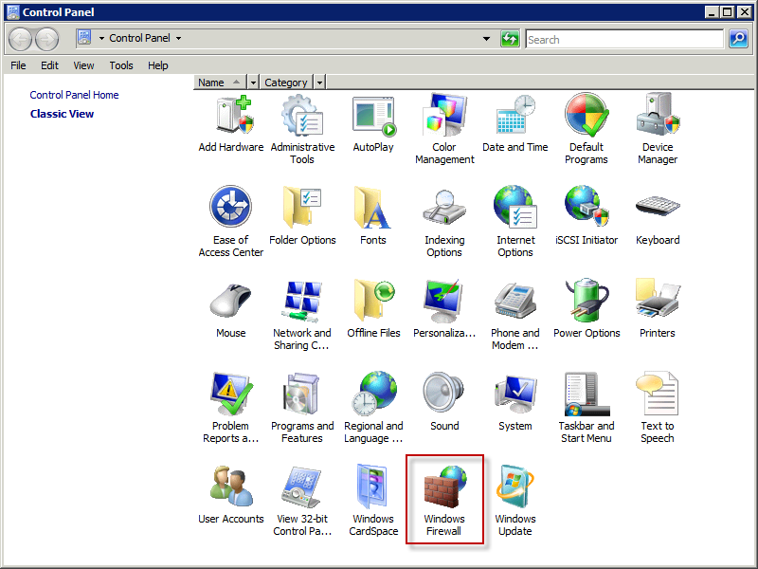

Click "Change settings" link.

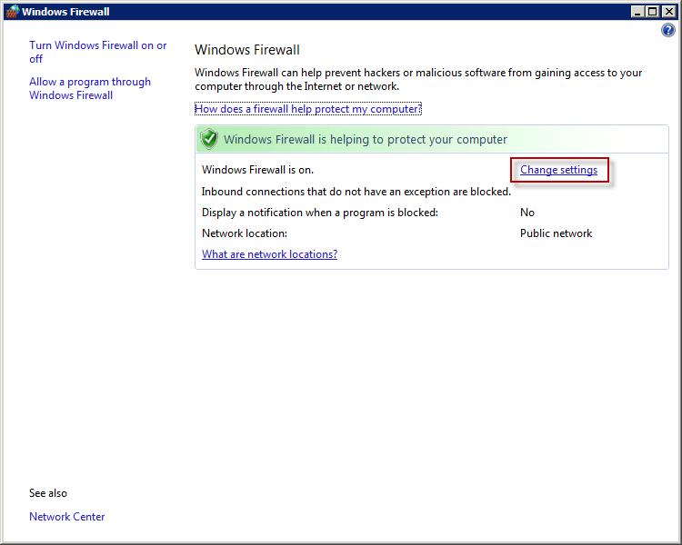

Switch to "Exceptions" tab and then click "Add port..." button:

[SCREENSHOT]

Specify exception name and 9001 port (or other one selected during WSP installation), protocol type is TCP. Click "OK" button twice to save changes and close snap-in.

### Configuring SQL Service to Work with Web App Gallery

If you plan to use Web App Gallery module in control panel you have to change SQL Server service settings in WebsitePanel to use SQL authentication.

Login to control panel under "serveradmin" account and open SQL Server service properties page (Configuration -> Servers -> service properties):

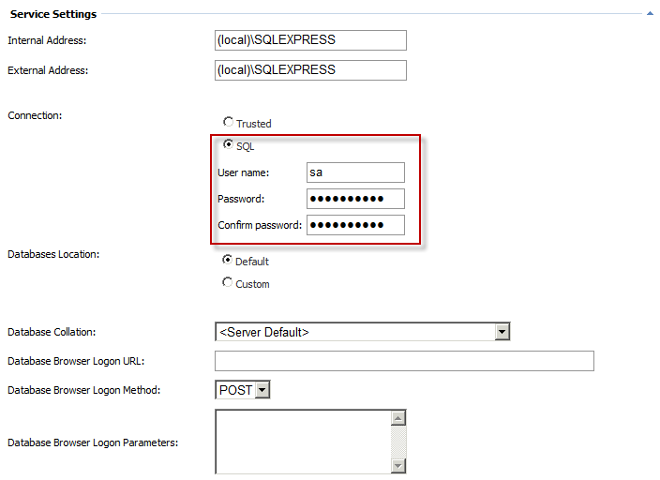

Select "SQL" connection option, provide SQL Server administrator user name ("sa" by default), its password and then click "Update" button to save changes.

### Configuring DNS Service to Support Custom Name Servers

If you are going to use your custom DNS name servers you have to specify them on DNS service properties in WebsitePanel.

Login to control panel under "serveradmin" account and open DNS service properties page (Configuration -> Servers -> service properties):

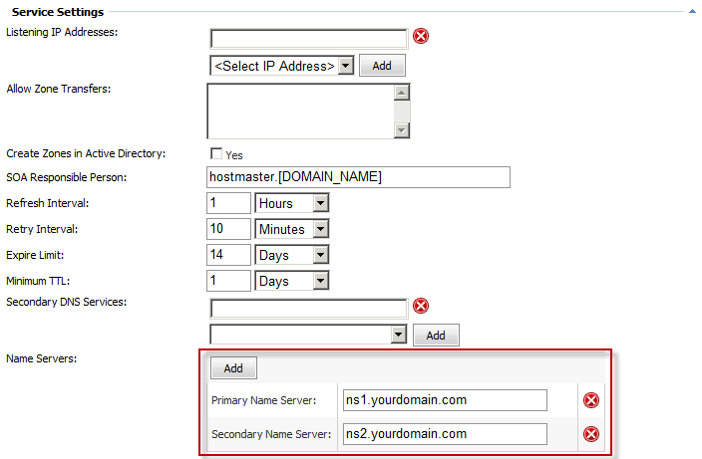

Specify your custom name servers in "Name Servers" section. Click "Update" button to save changes.

# Installing WebsitePanel Components One-by-One

## WebsitePanel Enterprise Server

To install WSP Enterprise Server open WSPI, click "View Available Components" button and then "Install" link over "WebsitePanel Enterprise Server" row:

[SCREENSHOT]

Click "Next" button to proceed to WSP ES installation wizard.

[SCREENSHOT]

WSPI will check for minimum system requirements and if they are met "Next" button will be enabled:

[SCREENSHOT]

Click "Next" button to switch to the next wizard step:

[SCREENSHOT]

Specify folder on server hard drive to install WSP ES files and click "Next" button to go to the next step:

[SCREENSHOT]

Specify WSP ES web site settings. If you are not going to expose Enterprise Server to external clients (3rd-party applications consuming ES web services) and WSP Portal will be installed on the same server we recommend keeping 127.0.0.1 as a web site IP address and default 9002 TCP port; otherwise you could select different IP address (from internal or external network pools) and TCP port for ES web site.

Click "Next" button to go to the next wizard step:

[SCREENSHOT]

"Security Settings" step allows you to specify the name of user account that will be used as ES web site anonymous identity (IIS 6 only) and ES application pool identity (IIS 6 and IIS 7). There is an auto-generated password for this account already specified in "Password" field. It's GUID and strong enough to be discovered. Change password value if only you are going to manually modify web site or application pool settings later after ES installation. If you are installing WSP Enterprise Server in Active Directory environment you have an option to "Create Active Directory account"; otherwise local Windows account (SAM database) will be created.

WSP Enterprise Server application pool must be run under "weak" user account. By default WSPI creates an account which is a member of "IIS_WPG" (on IIS 6) or "IIS_IUSRS" (on IIS 7) group only.

For WSP Enterprise Server we recommend creating "local" account for tightened security.

Click "Next" to go to "Database Settings" wizard step:

[SCREENSHOT]

Specify SQL Server 2005 or 2008 instance name in "SQL Server" field. For default SQL Server Express edition installation you could type "(local)\SQLEXPRESS", select authentication mode and specify database name.

Please note that these database settings will be used during WSP upgrades, so make sure they could be used to access SQL Server over time.

Click "Next" button to go to "Administrator Password" step:

[SCREENSHOT]

Specify password that will be assigned to "serveradmin" account. You use top-level "serveradmin" account to configure WebsitePanel installation and create resellers/customers.

Default "serveradmin" password pre-filled on this dialog is "serveradmin" (without quotes).  
We strongly recommend to replace default "serveradmin" password with your own strong one.

Click "Next" button to start the installation of WSP Enterprise Server:

[SCREENSHOT]

After ES setup is complete you will see the following dialog:

[SCREENSHOT]

You could click ES URL and open it in the web browser to make sure it was properly installed:

[SCREENSHOT]

## WebsitePanel Portal

To install WSP Portal open WSPI, click "View Available Components" button and then "Install" link over "WebsitePanel Portal" row:

[SCREENSHOT]

WSPI will check for minimum system requirements and if they are met "Next" button will be enabled:

[SCREENSHOT]

[SCREENSHOT]

Specify folder on server hard drive to install WSP Portal files and click "Next" button to go to the next step:

[SCREENSHOT]

Specify WSP Portal web site settings. The URL shown on this page will be used to access your control panel. If you have a free IP address assigned to the server then we recommend to dedicate it for control panel and specify "80" for the port; otherwise in the case selected IP is shared by several web sites we recommend you to leave default IP address and 9001 port.

Make sure the custom port selected for this web site (9001 in our case) is allowed on server Firewall.

Click "Next" button to go to the next wizard step:

[SCREENSHOT]

"Security Settings" step allows you to specify the name of user account that will be used as WSP Portal web site anonymous identity and WSP Portal application pool identity.

WSP Portal application pool must be run under "weak" user account. By default WSPI creates an account which is a member of "IIS_WPG" (on IIS 6) or "IIS_IUSRS" (on IIS 7) group only.

For WSP Portal we recommend creating "local" account for tightened security.

Click "Next" button to go to the next step:

[SCREENSHOT]

On this step you have to specify URL to WSP Enterprise Server application. For default WSP ES installation it's http://127.0.0.1:9002. To make sure WSP ES is accessible from the server where you are installing WSP Portal you could open its URL in the web browser.

Click "Next" button to start WSP Portal installation:

[SCREENSHOT]

After WSP Portal setup is complete you could see the dialog with installation log:

[SCREENSHOT]

You could click Portal URL and open it in the web browser to make sure it was properly installed:

[SCREENSHOT]

Try signing in under "serveradmin" (with appropriate password set during Enterprise Server installation) to make sure account home page could be accessed:

[SCREENSHOT]

## WebsitePanel Server

To install WSP Server open WSPI, click "View Available Components" button and then "Install" link over "WebsitePanel Server" row:

[SCREENSHOT]

WSPI will check for minimum system requirements and if they are met "Next" button will be enabled:

[SCREENSHOT]

[SCREENSHOT]

Specify folder on server hard drive to install WSP Server files and click "Next" button to go to the next step:

[SCREENSHOT]

Specify WSP Server web site settings. If you are installing WSP Server on the same server with WSP Enterprise Server we recommend keeping 127.0.0.1 as a web site IP address and default 9003 TCP port; otherwise you could select different IP address (from internal or external network pools) and TCP port for Server web site.

Click "Next" button to go to the next wizard step:

[SCREENSHOT]

"Security Settings" step allows you to specify the name of user account that will be used as WSP Server web site anonymous identity and ES application pool identity. There is an auto-generated password for this account already specified in "Password" field. It's GUID and strong enough to be discovered. Change password value if only you are going to manually modify web site or application pool settings later after Server installation. If you are going to control Active Directory from WebsitePanel and installing WSP Server in Active Directory environment you have an option to "Create Active Directory account"; otherwise local Windows account (SAM database) will be created.

WSP Server application pool runs under "strong" user account with administrative privileges. By default, WSPI creates account which is a member of local "Administrators" security group (for local mode) or "Domain Admins" security group (for AD mode).

[SCREENSHOT]

Click "Next" button to finish WSP Server installation. After Server setup is complete you will see the following dialog with installation log:

[SCREENSHOT]

You could click Server URL and open it in the web browser to make sure it was properly installed:

[SCREENSHOT]

## Troubleshooting Installation Issues

### Could not start WebsitePanel Installer on Windows 2008

This might be due to enabled User Account Control (UAC). As a solution you could disable UAC or run WSPI in "elevated" mode by right clicking its shortcut and selecting "Run as Administrator".

### Viewing WebsitePanel Installer Error Log

To view WSPI application log click "Application Settings" node in the left navigation menu and then click "View System Log" button:

[SCREENSHOT]

WSPI log will be opened in Notepad.

### "Unable to generate a temporary class" or "Root element is missing" error message while opening WSP Portal

This error is related to Windows Server 2003 platform. This error means that IIS_WPG group doesn't have Read and List Folder Contents permissions on C:\Windows\Temp folder on the server where WSP Portal is running. Just add IIS_WPG group with Read and List Folder Contents permissions on the mentioned folder on the WSP Portal server.

Please note that you should grant permissions to the domain IIS_WPG group if WSP Portal is running on domain controller or local IIS_WPG group in other cases.

Also note that it is good practice to grant those permissions to IIS_WPG on C:\Windows\Temp folder (or another folder in case of non-standard Environment Variables settings) on all servers running any WSP component.

### Web App Gallery cannot install ASP.NET applications with SQL Server database

Open SQL Server service settings in control panel and change security mode to "SQL Server Authentication". Specify "sa" username and its password and click "Update" button to save changes.

### WebsitePanel cannot create MailEnable mailbox on Windows 2003 x64 or Windows 2008 x64 editions

MailEnable and Merak mail server software are 32-bit applications providing COM API to WebsitePanel. If WSP Server component works in 64-bit mode it cannot instantiate 32-bit COM objects.

To solve this issue you have to switch ASP.NET on the machine where WSP Server is installed to 32-bit mode.

#### Switching ASP.NET to 32-bit mode on Windows 2003 x64

To switch IIS 6 and ASP.NET into 32-bit mode open command line:

Start -> Run... -> cmd

Then switch to c:\Inetpub\AdminScripts folder:

cd c:\Inetpub\AdminScripts

and run the following command:

cscript.exe adsutil.vbs set W3SVC/AppPools/Enable32BitAppOnWin64 "1"

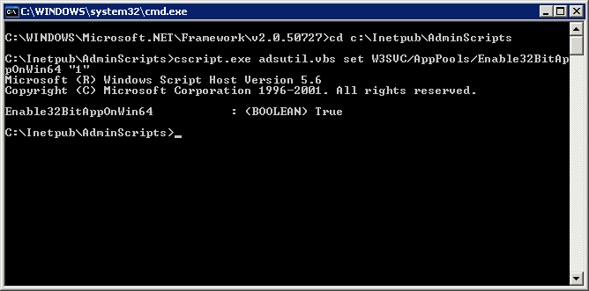

To enable ASP.NET on IIS in command line interface switch to C:\WINDOWS\Microsoft.NET\Framework\v2.0.50727 folder and run aspnet_regiis program with “i” switch:

cd C:\WINDOWS\Microsoft.NET\Framework\v2.0.50727

C:\WINDOWS\Microsoft.NET\Framework\v2.0.50727>aspnet_regiis -i

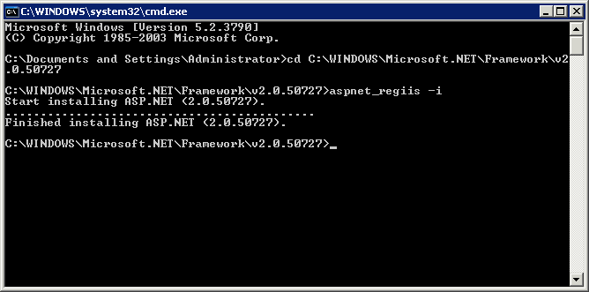

Now as ASP.NET is enabled for IIS you should go to Internet Information Services (IIS) Manager and allow “ASP.NET v2.0.50727 (32-bit)” extension in “Web Service Extensions” section:

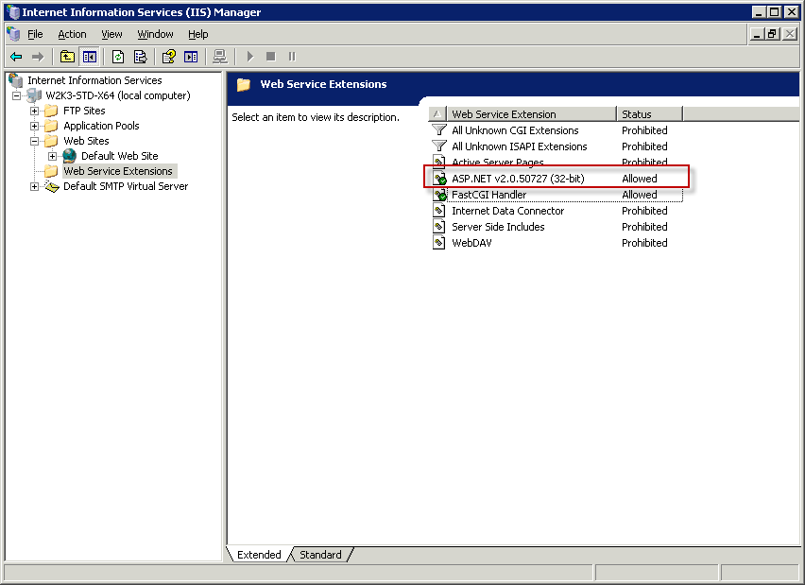

You could find more information regarding this topic in the following Microsoft KB:  
<http://support.microsoft.com/default.aspx/kb/894435>

#### Switching ASP.NET to 32-bit mode on Windows 2008 x64

To switch WSP Server application to 32-bit mode open IIS manager:

[SCREENSHOT]

Click "Application Pools" in the left navigation menu and then open "Advanced Settings" dialog of "WebsitePanel Server Pool":

[SCREENSHOT]

Set "Enable 32-bit Applications" to "True" and click "OK" button to save changes.

# Configuring WebsitePanel Components

## Changing WebsitePanel Web Site Settings

To change web site settings (listening IP addresses and port) for any WebsitePanel component open WebsitePanel Installer and click the component in the left navigation tree. Click "Settings" button on the component properties page:

[SCREENSHOT]

The first dialog of "Change Settings" wizard is "Web Settings":

[SCREENSHOT]

Specify or select new IP address to listen, specify TCP port and optional host name. Click "Next" button to save changes and go the next step. Skip all the rest of steps till the end of wizard.

## Changing Enterprise Server URL in Portal Settings

To work correctly WSP Portal must have a correct URL to Enterprise Server web site.

To change Enterprise Server URL in Portal settings open WebsitePanel Installer and click "WebsitePanel Portal" component in the left navigation tree. Click "Settings" button on the component properties page:

[SCREENSHOT]

Skip the first "Web Settings" dialog by clicking "Next" button:

[SCREENSHOT]

Change Enterprise Server URL and click "Next" button to continue wizard.

Default Enterprise Server URL is http://127.0.0.1:9002

## Changing Enterprise Server “serveradmin” Password

To reset control panel "serveradmin" password open WebsitePanel Installer and click "WebsitePanel Enterprise Server" component in the left navigation tree. Click "Settings" button on component properties page:

[SCREENSHOT]

Click "Next" button to skip the first "Web Settings" dialog:

[SCREENSHOT]

On "Set Administrator Password" dialog tick "Reset Serveradmin Password", specify new password and click "Next" button.

## Changing Server Access Password

If you are trying to register a new WSP Server instance on "Configuration -> Servers -> Add Server" page in control panel, but forgot password set during WSP Server installation you could easily reset it using WSP Installer.

To reset server access password open WebsitePanel Installer on the server where WSP Server is installed and click "WebsitePanel Server" component in the left navigation tree:

[SCREENSHOT]

Click "Settings" button on component properties page. Skip the first "Web Settings" dialog:

[SCREENSHOT]

On "Set Server Password" dialog tick "Reset Server Password", specify new password and click "Next" button.

# Upgrading WebsitePanel Components

To upgrade any WebsitePanel component you should use WSP Installer.

Open WSP Installer, select component in the left navigation menu and then click "Check For Updates" button on its properties page:

[SCREENSHOT]

If there are any updates available you will see the following confirmation dialog:

[SCREENSHOT]

Click "Yes" button to proceed with component upgrade.

Please note WSP Installer upgrades WSP component only to the next available version, but not to the most recent one. If you need to update WSP component to the most recent version you have to click "Check For Updates" button once again.

## Troubleshooting Upgrade Issues

If you experiencing any issues right after WSP update try the following basic troubleshooting steps:

1. Make sure all WSP components were upgraded to the same version.
2. Reset WebsitePanel components application pools:  
   [SCREENSHOT]

# Document History

|  |  |  |  |
| --- | --- | --- | --- |
| Version | Date Released | Author | Changes |
| 1.0 | 04/15/2010 | Feodor Fitsner | Initial document version in downloadable format. The guide is built for WSP 1.0 |